Result and Transcript Processing System (RTPS)

By

Dr. E. Olaye

Eddie.olaye@gmail.com

Features

# Uploading Results

Single click imports of result from excel file

Result checker

Customizable result template

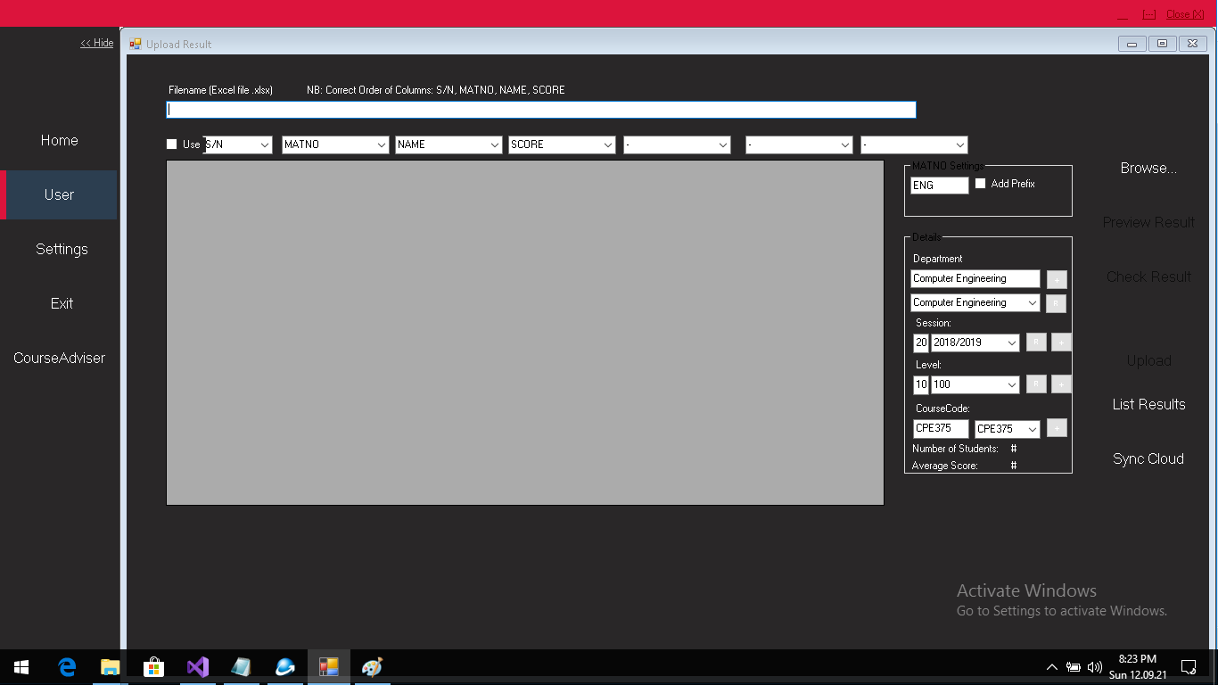

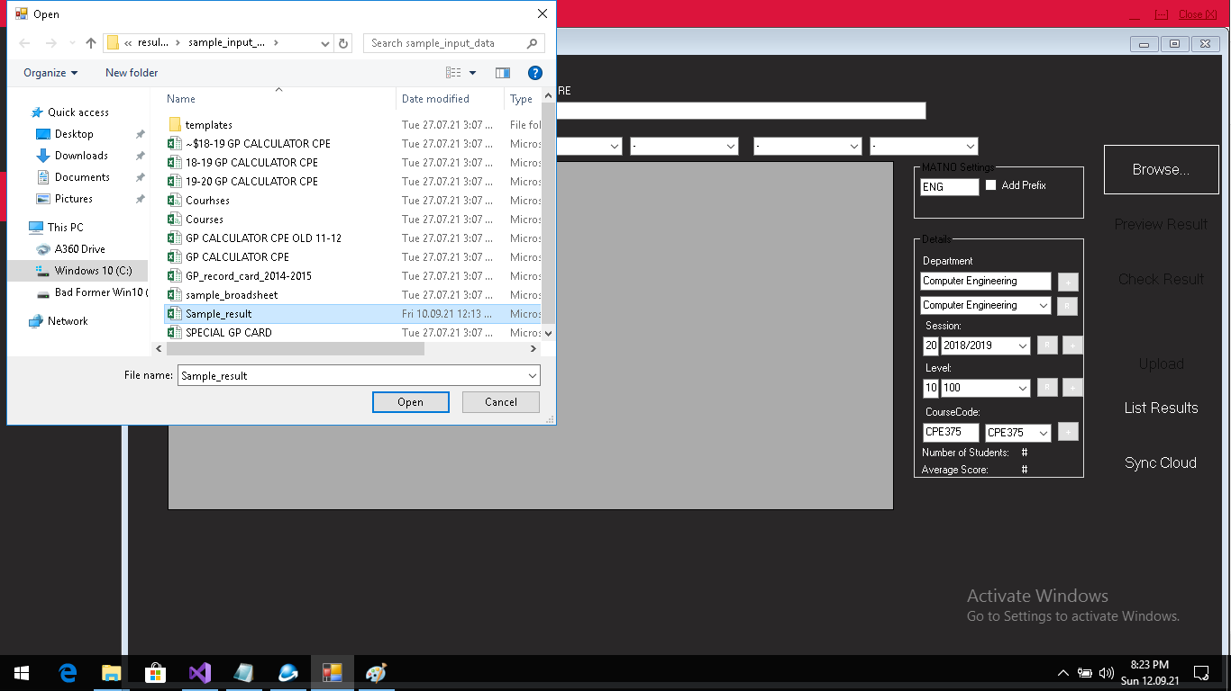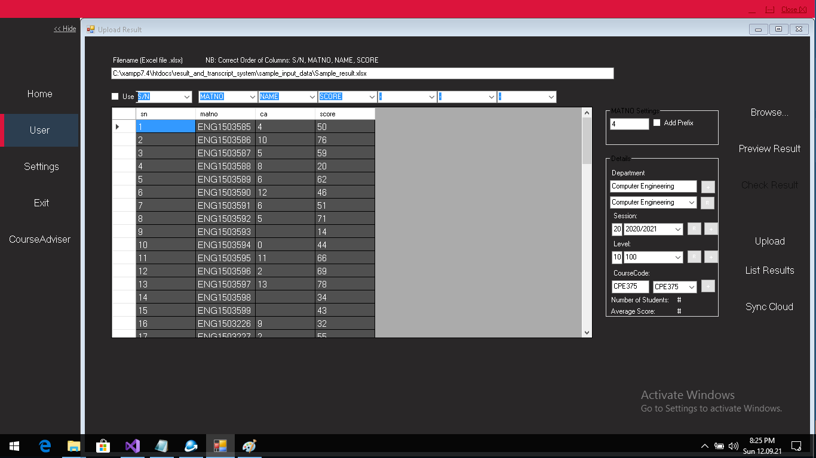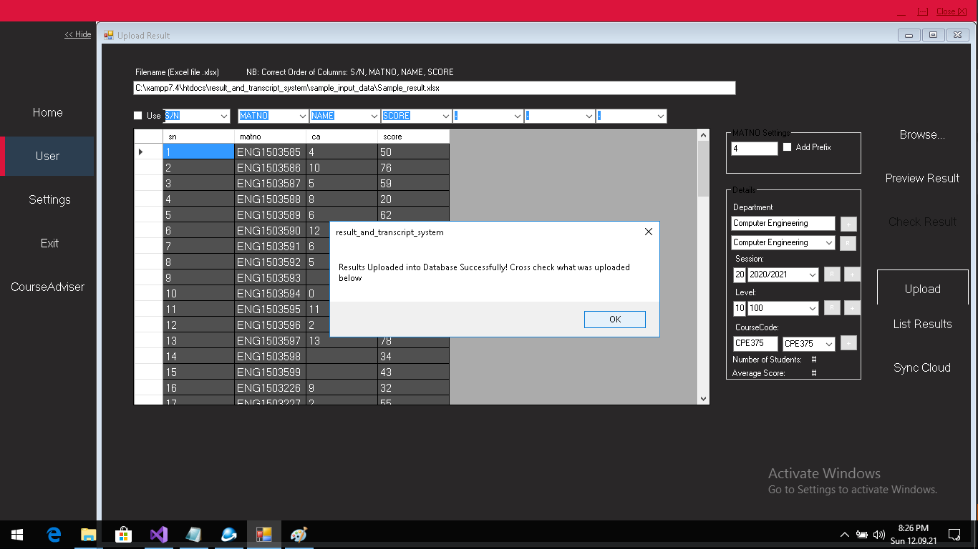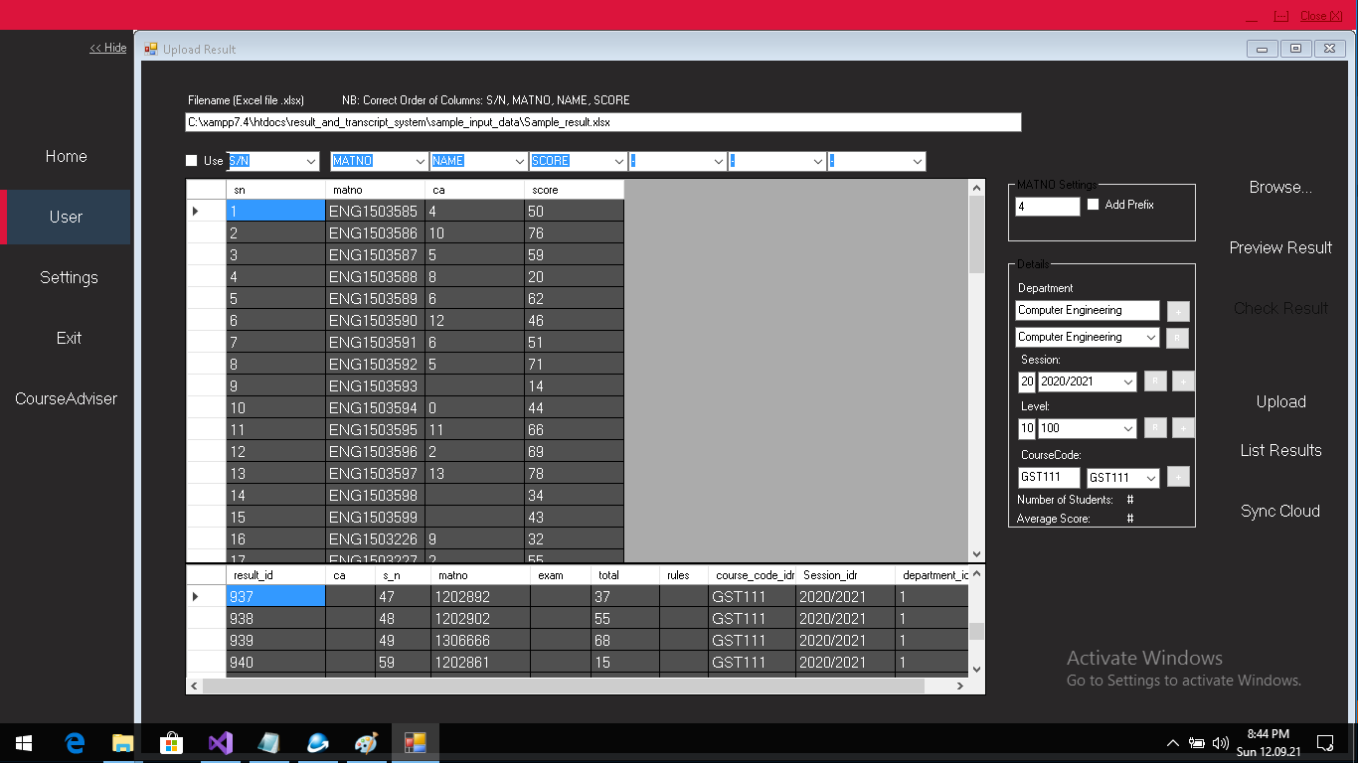

# Broadsheet Generation

Single Click Fully automated

Customizable template

Database storage

Flexible: Adjustments can be made by authorized user

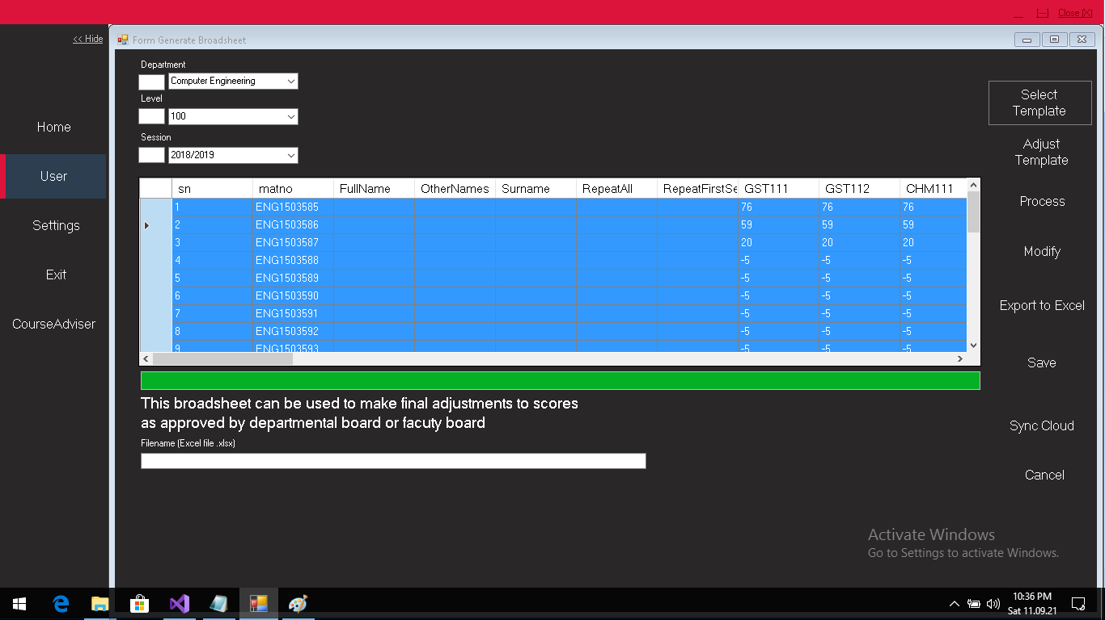

# BroadSheet Sample Output

## Features

Slash notation for repeated course

Faculty format

Customizable with familiar Excel software

Compact and elegant

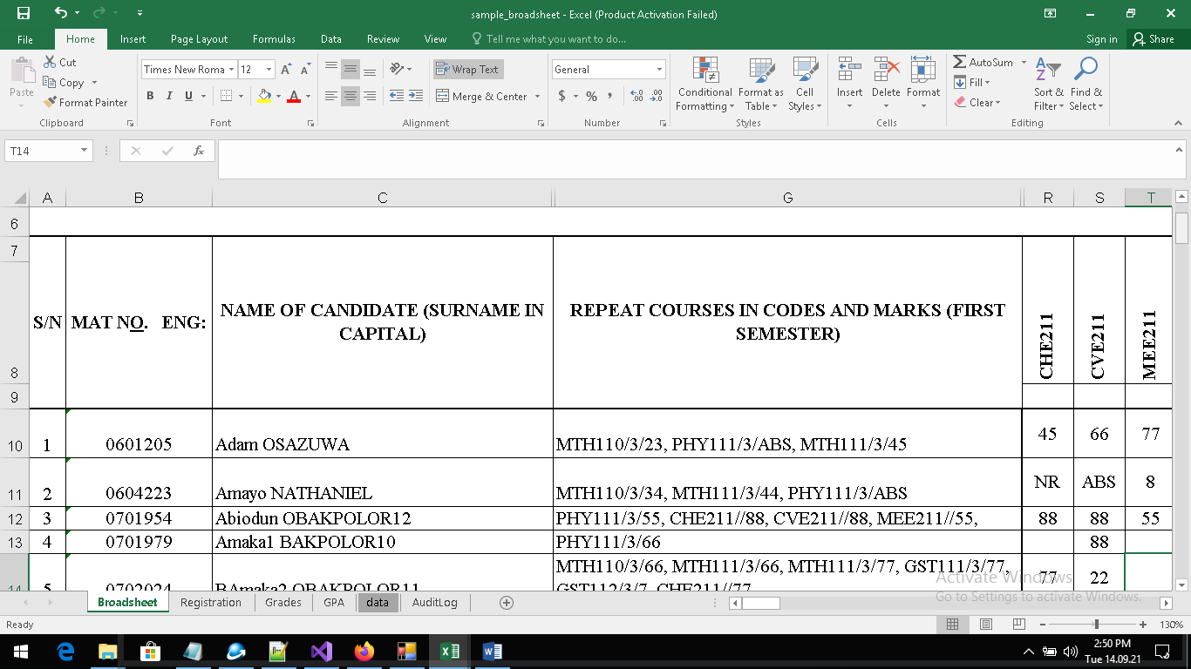

Supports direct export to PDF

# Audit Trail

Encryption Schemes

Tracking of every change to results in database

Audit logs

# Broadsheet Generation

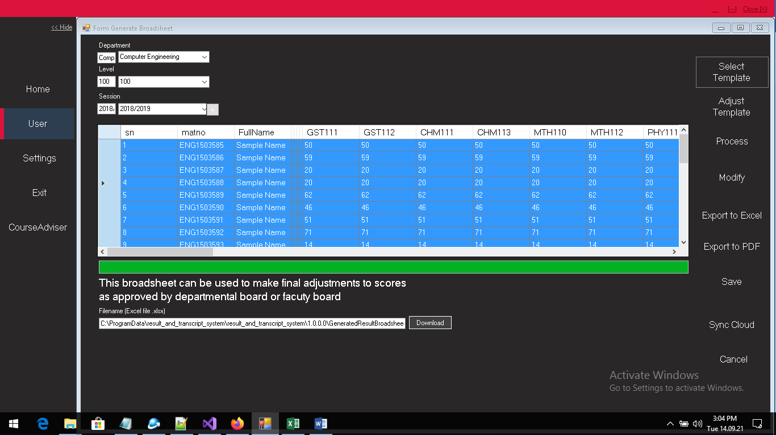

# Course Adviser

# Student’s Registration

Easy to use

Accepts registration data from other sources

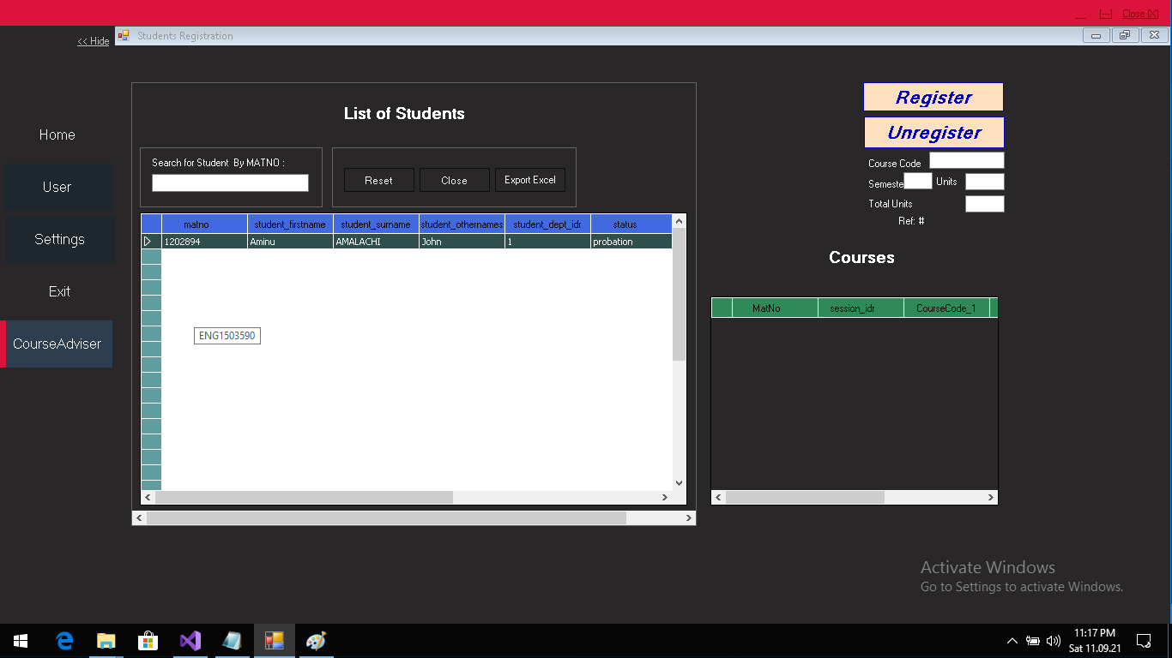

# Other Features

Senate version

GPA computation

Transcripts